IOT ENABLED SMART HOME

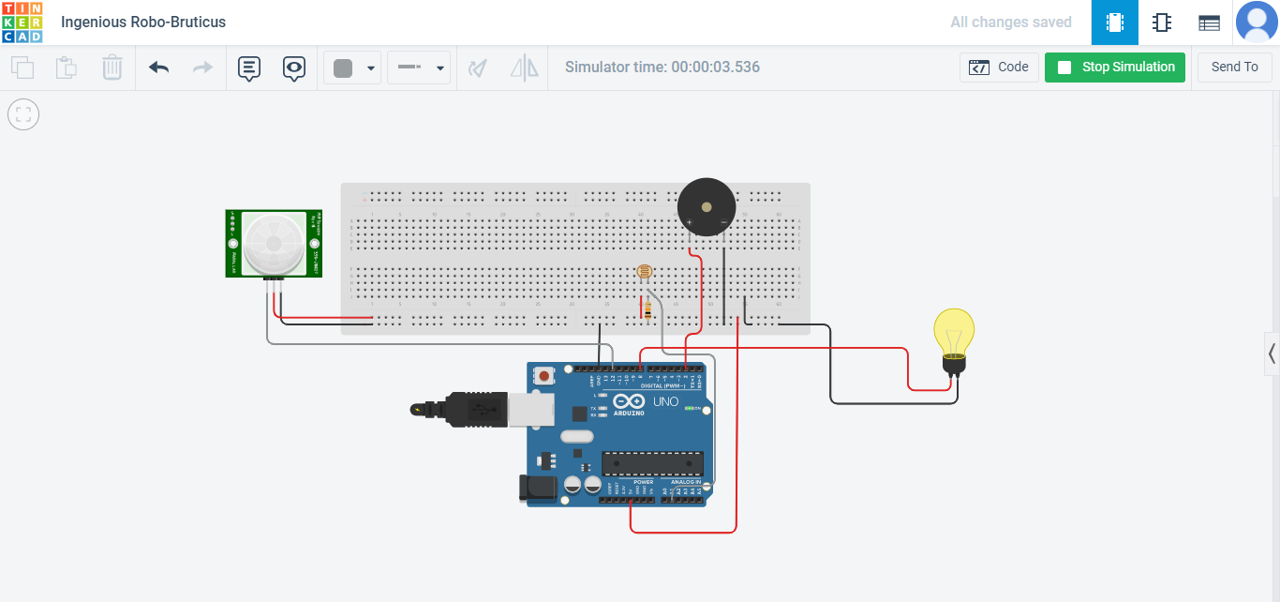

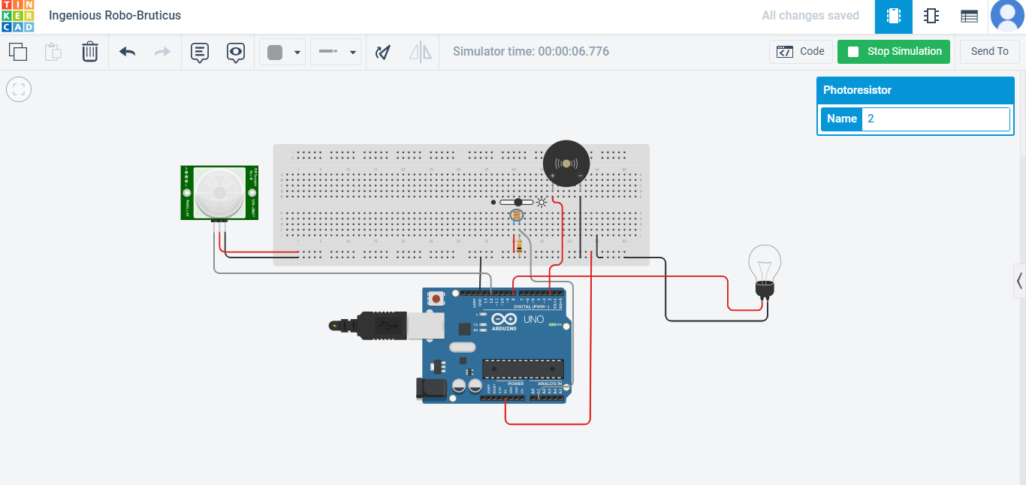

int redPin=8,buzzerPin=2;  
int ldrPin=A1,pirPin=12;  
int delaytime=250;  
int readVal1,readVal2;  
void setup()

{  
 pinMode(redPin, OUTPUT);  
 pinMode(buzzerPin, OUTPUT);  
 pinMode(ldrPin, INPUT);  
 pinMode(pirPin, INPUT);  
 Serial.begin(9600);  
}

void loop()

{  
 readVal1 = analogRead(ldrPin);  
 readVal2 = analogRead(pirPin);  
 Serial.print(readVal1);  
 Serial.print(readVal2);  
 if(readVal1 > 800)

{  
   
 digitalWrite(redPin,LOW);  
 digitalWrite(buzzerPin,HIGH);

}

else if(readVal1 < 800 )

{  
   
 digitalWrite(redPin,HIGH);  
 digitalWrite(buzzerPin,LOW);

}  
 Serial.println();  
  
}